
Lab Report
Department: Department of Computer Science and Engineering
Course Title: Computer Networks Lab
Course Code: CSE0612314
Experiment No.: 04
Experiment Title: Router Configuration using CLI.

Submitted to:
Teacher’s name: Trisha Sarkar
Designation: Lecturer
Department of CSE
UITS

Submitted by:
Student name: Badhon Kumar Roy
Student Id: 04324205101042
Section: 5A2
Semester: Autumn 2026
Batch: 56th
Date of Submission: 13 September, 2026
Laboratory Report
1. Experiment Number: 04
2. Experiment Title: Router Configuration using CLI.

3. Objectives:
- To learn how to access the router CLI using Cisco Packet Tracer.
- To understand basic IOS commands used for router configuration.
- To configure a hostname and passwords on the router.
- To assign IP addresses to router interfaces using CLI commands.
- To verify the configuration using show running-config and show ip interface brief.
4. Theoretical Background:
Cisco IOS (Internetwork Operating System) is the software that runs on Cisco routers and switches, and it can be accessed through the Command Line Interface (CLI) to configure and manage the device. Unlike the GUI-based configuration used earlier, CLI configuration involves typing specific commands to set up the router manually, which gives more control and is closer to how real network engineers work. Basic configuration includes setting a hostname to identify the router, applying passwords to secure console and privileged EXEC access, and assigning IP addresses to the router's interfaces so it can communicate with connected networks. Commands like show running-config and show ip interface brief are used to verify that the configuration has been applied correctly. Learning CLI-based configuration is an important step in understanding real-world router management beyond just simulation.
5. Tools and Software used:
- Cisco Packet Tracer,
- PC-PT,
- PT8200 Router,
- Command Line Interface (CLI),
- Wires.

6. Network Topology:
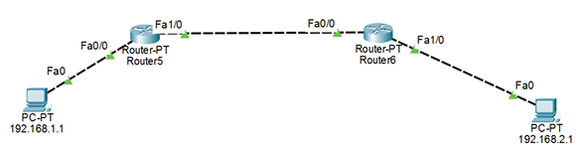
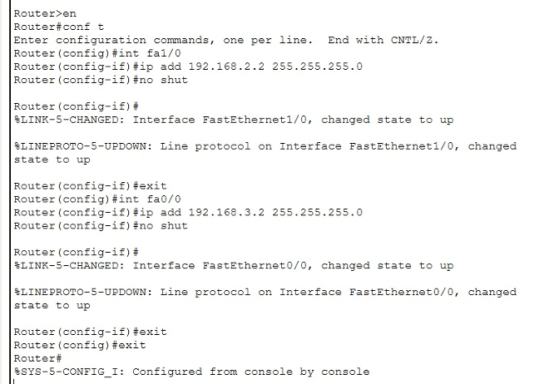
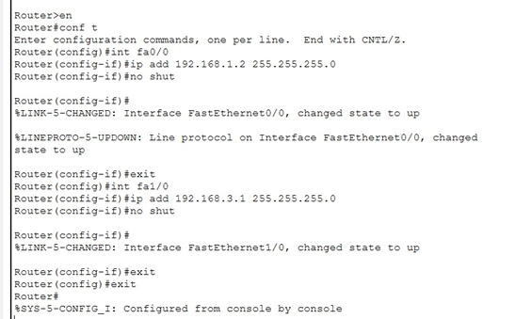
Figure 4.1: PC connected to Router via Console cable for CLI access.

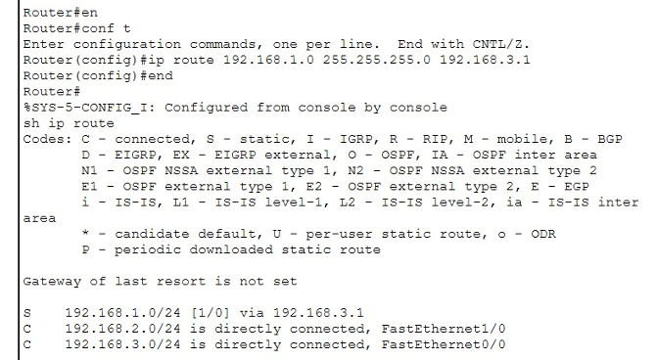
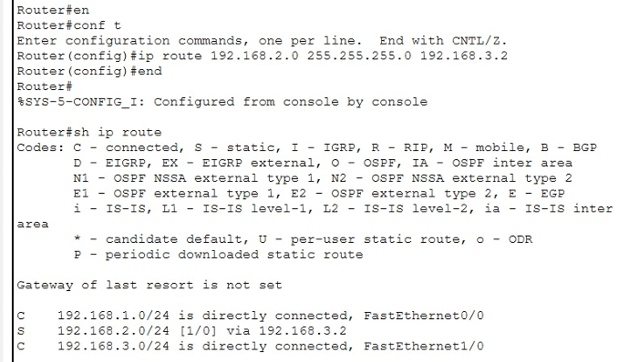
Figure 4.2: Router1 and Router2 Configuration Using CLI.
Figure 4.3: Router1 and Router2 IP Route.
7. Methodology:
- At first, we opened Cisco Packet Tracer and placed a Router and a PC on the workspace.
- Connected the PC to the router's console port using a console cable.
- Opened the Terminal on the PC through the Desktop tab to access the router CLI.
- Entered privileged EXEC mode using the enable command.
- Entered global configuration mode using the configure terminal command.
- Set the router's hostname using the hostname command.
- Configured console and enable passwords using line console 0 and enable password/secret commands.
- Entered interface configuration mode and assigned an IP address to the router interface using the ip address command, then enabled it with no shutdown.
- Saved the configuration using the copy running-config startup-config command.
- Verified the configuration by running show running-config and show ip interface brief commands.
- Took screenshots of the CLI commands and their outputs for documentation.
8. Output:
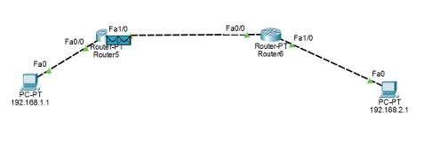

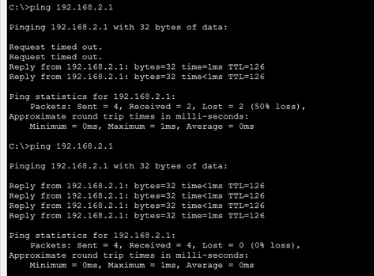
Figure 4.4: Simulation Mode

Figure 4.5: CMD Ping Results
9. Conclusion:
This experiment helped in understanding how to configure a router directly through the CLI instead of relying only on GUI-based setup. By setting the hostname, passwords, and interface IP addresses using basic IOS commands, it became clear how routers are actually configured in real networking scenarios. Verifying the configuration with show running-config and show ip interface brief confirmed that all settings were applied correctly. Overall, the experiment gave hands-on experience with essential CLI commands, which is a fundamental skill for managing Cisco devices.

